Create your Apple ID on a Mac or PC

1. Open iTunes, then go to the iTunes Store by clicking the iTunes Store button at the top of the window.  
   
2. Scroll down and find the country flag in the lower-right corner of the window. If it's not the flag of the country where you live, click it and choose your country or region.  
   
3. Go to the App Store, Music, TV Shows, or Books section of the store by clicking on one of the icons in the upper-left corner.  
   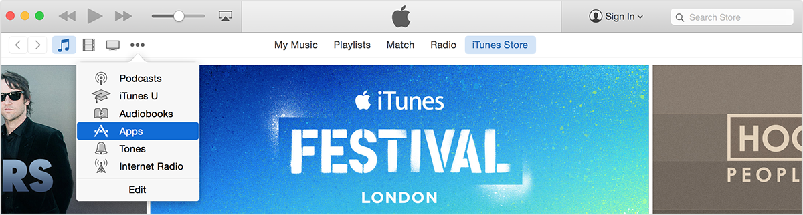
4. Download a free app, song, video, or book. To find free items, look in the right column of the window and click any link that includes the word "Free," such as "Free on iTunes" or "Top Free." When you find a free item, click Get beneath its icon.  
   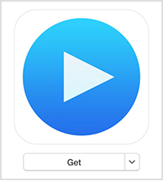
5. When you're asked to sign in with an Apple ID, click Create Apple ID.  
   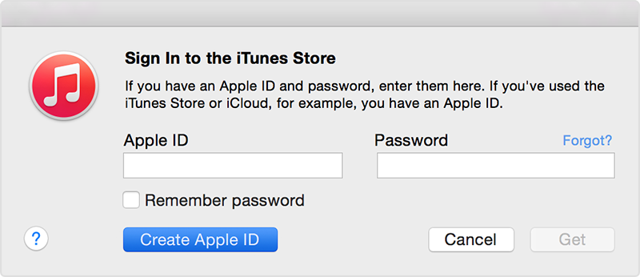
6. Follow the onscreen instructions. When you're asked for payment information, choose None as the payment type. [See what to do if None isn't showing or you can't select it.](http://support.apple.com/kb/TS5366)   
   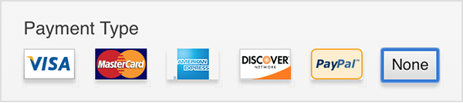

**What to do if None isn't showing or you can't select it.**

If you're using the iTunes Store or App Store for the first time

If you're [using the store for the first time with an existing Apple ID](http://support.apple.com/kb/HT2589), you must provide a payment method. After you create the account, you can [change your payment information](http://support.apple.com/kb/HT1918) to None.

1. After you enter all of the information required, you'll be asked to verify your Apple ID by email. You must verify your Apple ID before you can begin using it.